Introduction to the Household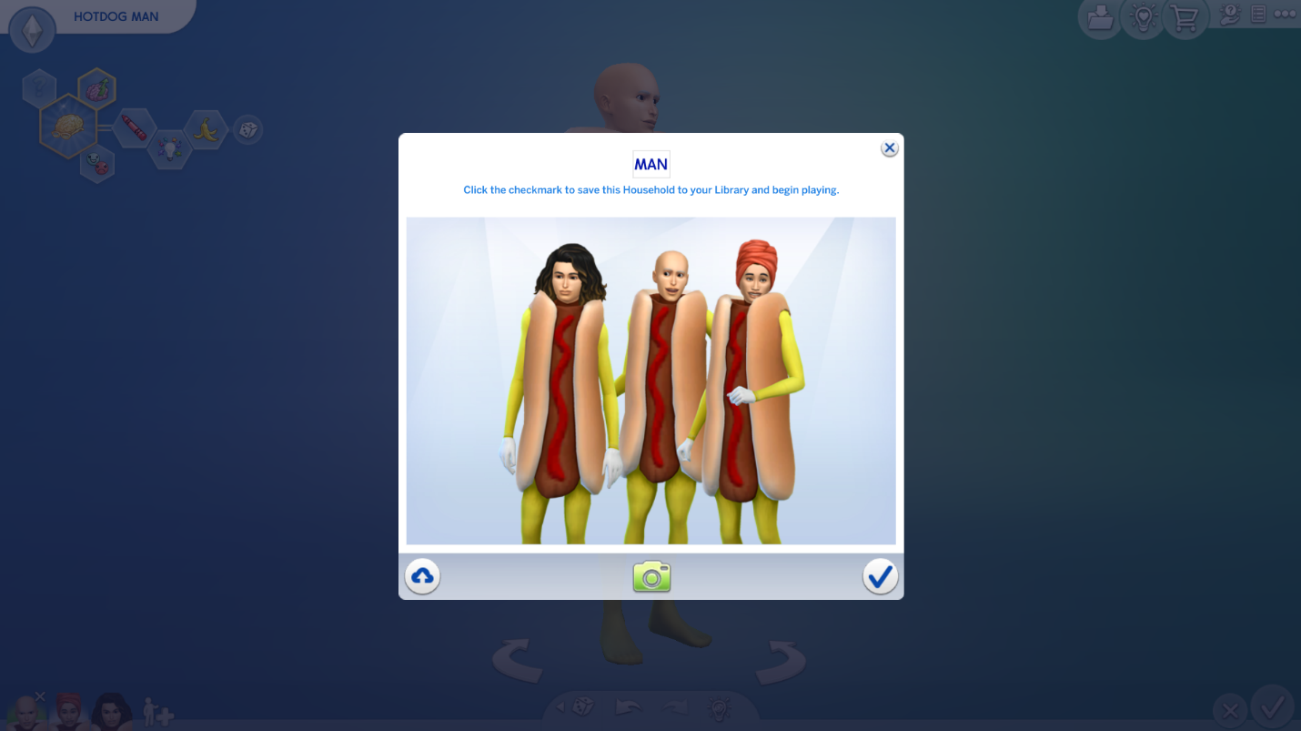
The one of the center is Hotdog Man. He is the father of his daughter, which one of the left.
He is childish, clumsy and goofball man however his aspiration is to being nerdy. He likes to listen to Kids Radio Music.
The one of the right is Hotdog Women. She is the mother. She is erratic, goofball and glutton women and her aspiration is to being master chef. She likes to cook.
The one of the left is Kuso Gaki. She is the daughter of parents that explained previously, and she is goofball and vegetarian. Due to being vegetarian, she cannot eat hotdogs despite her looks. Her aspiration is to being angling ace and she likes fishing. However, she is vegetarian.

